# ERM Walk Thru

## Entity Relationship Model

An entity-relationship model (ERM) is a theoretical and conceptual way of showing data relationships. ERM is a database modeling technique that generates an abstract diagram or visual representation of system’s data that can be helpful in designing a relational database

## Example Restaurants

We have the tables: Location, Employees, MenuItems

** Use the name of the entity in front of each of the fields so that the data is clear

**Locations Table**

* LocationID PK
* LocationName
* LocationStreetAddress
* LocationManager
* LocationCity
* LocationProvince
* LocationPostalCode

**Employees**

* EmployeeNumber PK
* EmployeeFirstName
* EmployeeLastName
* EmployeeDOB
* EmployeeJobRole

**MenuItems**

* MenuItemID PK
* MenuItemName
* MenuCategory
* MenuPrice
* MenuCost
* Now we have to identify how each of these tables are related

Transactions:

* TransactionID PK
* TransactionsCustomerName
* TranscationsVisitDate
* TransactionsVisitTime
* LocationID FK
* EmployeeNumber FK
* MenuItemID FK

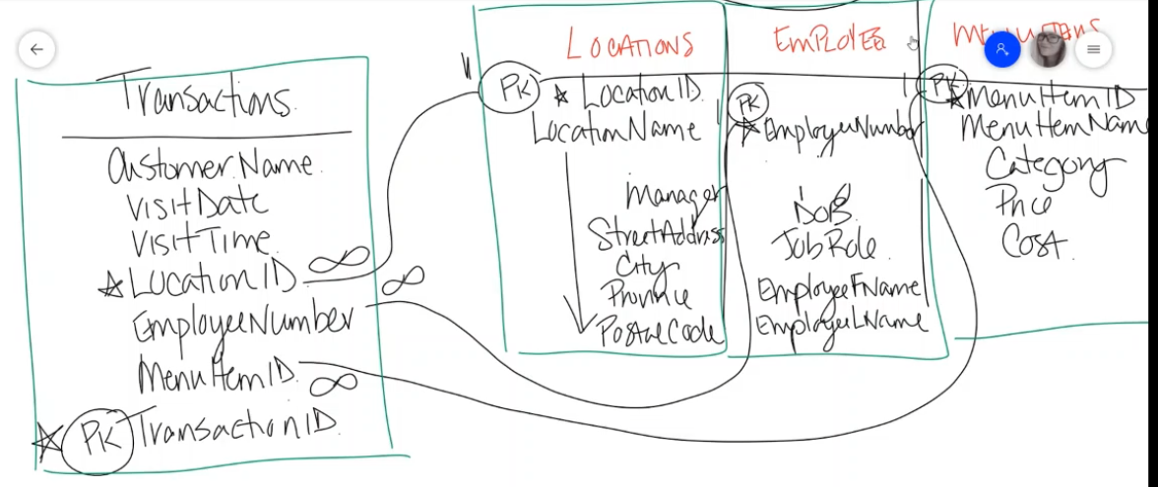

* Why did we set it up this way? This allows us to store information at the right level of granularity and becomes helpful later on when we need to summarize the information later. We store information in this transaction. We can take the sales transaction information and we can group it by any field or any attribute that is in the locations table. We can look at menu items sales by city. Then we can see if there is a different in popularity in MenuItems based on the number of cities that they operate at. Do people in different provinces eat differently? We can relate the employee number to the sales of MenuItems